**「大灣區****維護套餐」 – 香港有限公司維護服務申請表 (創業者同盟專用)**

**“Greater Bay Area Maintenance Package” – HK Limited Company Maintenance Service Application Form (Association Members Only)**

|  |  |  |  |
| --- | --- | --- | --- |
| **商會或創業者同盟會員資料　Association Membership Information** | | | |
| 會員名稱 Name | Click Here to Enter Text | 會員號碼 Association Membership No. | Click Here to Enter Text |
| **選用「大灣區港創套餐」之客戶必須填報以上兩項商會或創業者同盟會員資料，如填報之申請人符合申請條件，而資料亦經查核為真確，客戶方可取得申請「大灣區港創套餐」的資格。**  **Customer who chooses “Greater Bay Area Entrepreneur HK Package" must fill in the association membership information above. You will be qualified for the application of “Greater Bay Area Entrepreneur HK Package” only if the applicant meets the application conditions and the above association information provided is verified as true.** | | | |

|  |  |  |  |  |  |
| --- | --- | --- | --- | --- | --- |
| **公司資料　Company Information** | | | | | |
| 公司註冊號碼 Company Registration Number | Click Here to Enter Text | | 商業登記證號碼 Business Registration Certificate Number | | Click Here to Enter Text |
| 公司名稱 Company Name | 英文名稱 English Name | Click Here to Enter Text | | | |
|
| 中文名稱 Chinese Name | Click Here to Enter Text | | | |
|
| 是否會計妹®之現有/舊客戶？ Are you an existing/old client of AccGirl?  *如答案為 “是”，必須填寫客戶編號*  *Must provide Client Code if answer is “Yes”* | | Select | | 客戶編號 Client Code | Enter Here |
| 會計年度終結日 Financial Year End Date | 31st Mar　　　  31st Dec　　　  自訂日期　Customized Date:　Select Date  *建議日期為成立公司後十五個月內　15 months after incorporation will be the suggested date* | | | | |

|  |  |  |  |  |  |  |
| --- | --- | --- | --- | --- | --- | --- |
| **申請人及公司聯絡人資料**  **Applicant and Main Contact Person Information** | | | | | | |
| 申請人身份 Applicant’s Position | 股東Shareholder　  董事Director　  公司秘書Company Secretary  重要控制人 Significant Controllers  *唯一董事不能兼任公司秘書　A sole director cannot be the Company Secretary* | | | | | |
| 英文姓名 Full Name in English | Enter Here (E.g.: CHAN Tai Man/CHEN Dawen) | | | | 持股量  Number of Shares | Enter Here (只適用於股東)  (Shareholder only) |
| 中文姓名 Full Name in Chinese | Click Here to Enter Text | 性別 Gender | Select | |
| 身份證/護照號碼 I.D. / Passport No. | Click Here to Enter Text | 簽發國家 Issuing Country | | | Click Here to Enter Text | |
| 聯絡電話 Contact Number | Click Here to Enter Text  **WhatsApp** | 其它國籍 (如適用)  Other Nationality  (If Applicable) | | | Click Here to Enter Text | |
| 住址/聯絡地址 Residential / Correspondence Address  (董事必須提供住址　Director must provide residential address) | Flat/Room, Floor, Block, Building  Street No.  Complex/Community, District  Country | | | | 即時通訊軟體Instant Messenger | Select |
| 用戶名/號碼  AC Name / No. | Enter Here |
| 電郵地址 E-mail | Click Here to Enter Text | | | | | |
| 資金來源 Source of Funds | 公司營業收入及利潤 Business Income and Profit  個人儲蓄/投資 Personal Savings/Investments  實益擁有人/合夥人的投資  Investment by Ultimate Beneficial Owner/Partner | | | 出售物業/資產 Sale of Property/Asset  繼承財產 Inheritance  集團內部融資 Intra-Group Financing  其他 Others:　 Enter Here | | |
| *需提供注入公司的資金來源證明文件　Please provide us with the supporting documents of the source of funds to be injected into the Company* | | | | | |

**注意：必須填寫此申請表內所有空格 (不適用者請以“N/A”表示)** **Caution: All boxes on this application form must be filled out (if not applicable, put “N/A”)**

請在適當的方格內填上(✓)號或(x)號以表示你的選擇　Please check (✓) or cross (x) the appropriate box to indicate your preference

|  |  |  |  |  |  |  |  |  |
| --- | --- | --- | --- | --- | --- | --- | --- | --- |
| **重要控制人登記冊及指定代表資料**  **Significant Controllers Register and Designated Representative Information** | | | | | | | | |
| **重要控制人　Significant Controllers** | | | | | | | | |
| 英文姓名 Full Name in English | Click Here to Enter Text | | 中文姓名 Full Name in Chinese | | Click Here to Enter Text | | | |
| 身份證/護照號碼 I.D. / Passport No. | Click Here to Enter Text | | 簽發國家 Issuing Country | | Click Here to Enter Text | | | |
| 聯絡電話 Contact Number | Click Here to Enter Text | | 手提電話 Mobile Number | | Click Here to Enter Text | | | **WhatsApp** |
| 住址/聯絡地址 Residential / Correspondence Address  (董事必須提供住址　Director must provide residential address) | Flat/Room, Floor, Block, Building  Street No.  Complex/Community, District  Country | | | | 即時通訊軟體Instant Messenger | | Select | |
| 用戶名/號碼  AC Name / No. | | Enter Here | |
| 電郵地址 E-mail | Click Here to Enter Text | | | | | | | |
| 對公司的重大控制權  Significant Control Over The Company  *(見附件一填寫表格指引)*  *(See Guidelines in Appendix A)* | | 直接或間接持有公司 25% 以上的已發行股份  　 Holds directly or indirectly more than 25% of the issued shares in the company  其他 Others: Please describe | | | | | | |
| **指定代表　Designated Representative** | | | | | | | | |
| 指定代表  Designated Representative  *(見附件一填寫表格指引)*  *(See Guidelines in Appendix A)* | (不需填寫下方指定代表資料) 上述長居香港主要聯絡人 (Not required to fill in the Designated Representative Information below) Main contact person chosen above who resides in Hong Kong | | | | | | | |
| Full Name in Chinese & English | | | Contact No. & E-mail | | I.D./Passport No. | | |
| Correspondence Address | | | | | | | |

|  |  |  |  |
| --- | --- | --- | --- |
| **虛擬辦公室服務管理 (如適用)　Virtual Office Service Management (If applicable)** | | | |
| **郵件/包裹代收服務　Mails/Parcels Handling Service** | | | |
| 郵件/包裹通知  Mails/Parcels Notification | 電郵地址　Email Address:　 Click Here to Enter Text  If differ from contact email 若與聯絡電郵不一  *如閣下選用本公司之虛擬辦公室服務，本公司將協助貴公司直接處理所有來自公司註冊處及稅務局之信件。*  *For Virtual Office Service, AccGirl will help your company directly handle all letters from the Registrar of Companies and the Inland Revenue Department.* | | |
| **電話服務 　Phone Call Service** | | | |
| 歡迎語 Greetings | 英文　English  中文　Cantonese  普通話　Mandarin | | |
| 來電處理安排  Call Arrangement | 系統直接轉駁至指定聯絡人; **我不需要留言信箱服務 I do not need Voicemail Service \*\*\***  　　Direct transfer to assigned contact person  　接聽後即時轉駁至指定號碼，不成功便以 **Email / WhatsApp / WeChat**  **\*\*\*** 通知口訊  　　Transfer to assigned contact person after picking up. Notify by if fail  　接聽後留下對方聯絡號碼及口訊，以 **Email / WhatsApp / WeChat**  **\*\*\*** 通知  　　Leave contact number and message, notify by  (本公司會儘量因應客戶的要求作出安排　We will try our best to implement the arrangements) | | |
| 第一指定聯絡人 First Assigned Contact Person:  第二指定聯絡人 Second Assigned Contact Person: | -- Select Applicant--  -- Select Applicant-- | Remark  Remark |
| 首位公司聯絡人免費，之後每增加一位聯絡人，每月將收取HKD50服務費  An additional of HKD50/month per person will be charged if there is more than 1 contact person | | |
| **傳真服務　Fax Service** | | | |
| 傳真通知 Fax Notification | 電郵地址　Email Address:　 Click Here to Enter Text | | |

**\*\*\* 請選擇 *** Please select**

**注意：必須填寫此申請表內所有空格 (不適用者請以“N/A”表示)** **Caution: All boxes on this application form must be filled out (if not applicable, put “N/A”)**

請在適當的方格內填上(✓)號或(x)號以表示你的選擇　Please check (✓) or cross (x) the appropriate box to indicate your preference

**「大灣區維護套餐」服務計劃內容 (只需HKD8,888+)**

**“Greater Bay Area Maintenance Package” Service Plan Information (HKD8,888+ Only)**

|  |  |  |  |  |
| --- | --- | --- | --- | --- |
| **包括服務**  **Services Included** | **服務資料**  **Service Information** | | | **服務升級**  **Service Upgrade** |
| **公司秘書服務 (一年期)　Company Secretary Service (1-Year)** | | | | |
| 高級法定秘書服務套餐 | 服務詳情請參考**第7頁**(附件二)之服務計劃內容  Please see **page 7** (Appendix B) for service plan information | | |  |
| 週年申報費 (政府收費)  Annual Fee (Government Charge) | 存放以支付下一年度週年申報費用  Depositing the next two annual return filling fees charged by the government | | |  |
| 商業登記費 (政府收費)*  Business Registration Fee (Government Charge)* | 商業登記續期費用 (如適用)  Business Registration Fee (if applicable) | | | -- Select -- |
| **虛擬辦公室服務 (一年期)　Virtual Office Service (1-Year)**  *本公司將協助貴公司直接處理所有來自公司註冊處及稅務局之信件。*  *AccGirl will help your company directly handle all the letters from the Registrar of Companies and the Inland Revenue Department.* | | | | |
| 虛擬辦公室服務  Virtual Office Service | 選擇一:  Selection 1: | 實惠套餐  Economic Package | 服務詳情見**第8頁**(附件三)  See **page 9** (Appendix C) for service details | 默認選擇一 Default Selection 1 |
| 選擇二:  Selection 2: | 優越套餐  Premium Package | 服務詳情見**第8頁**(附件三)  See **page 9** (Appendix C) for service details |
| 公司水牌  Company Name Plate | 公司水牌租用 (包公司水牌製作費)  Company Name Plate Rental (Name plate production fee included) | | |  |
| 按金  Deposit | 申請人可選擇是否存放HKD200按金以支付代墊郵/運費用，按金可於服務終止日算起一個月內退還  Applicant(s) may deposit HKD200 for postage/courier charges. Refundable in one month after date of termination of service | | | -- Select -- |
| **會計理帳及報稅服務　Accounting & Bookkeeping & Tax Services** | | | | |
| 會計理帳服務優惠  Accounting Service | 每年0至50個交易項目 (交易項目超出50個費用另議)  0 – 50 transactions per year (Discussed separately if transactions exceed 50)  請參考以下網站以了解交易項目計算方法 Visit the link below for calculation method of transactions  <http://www.accgirl.com/page.php?18> | | |  |
| 免費稅務代表 (一年)  Free Tax Representative (1-Year) | 稅務代表作用主要為代表客戶向政府部門溝通及處理有關稅務事宜，有效地為客戶減輕稅務方面的煩惱。  Tax representative helps communicate with the Inland Revenue Department on behalf of clients to deal with tax matters, effectively reduces tax troubles. | | |  |
| **由第三方提供之服務　Service provided by third parties** | | | | |
| 首年審計服務  First-Year Auditing Service | 審計服務由第三方 (香港會計師公會註冊及認可提供法定審計服務之會計師事務所) 提供  Auditing services are to be provided by third parties (registered accounting firms of Hong Kong Institute of Certified Public Accountants qualified to provide statutory auditing services) | | |  |

|  |  |  |  |
| --- | --- | --- | --- |
| **其他熱門服務!!!　Other Popular Services!!!** | **價格　Service Price** | | **服務升級**  **Service Upgrade** |
| 重要控制人之指定代表 (一年期)  Designated Representative of Significant Controllers (1-Year)  擔任重要控制人登記冊內重要控制人之指定法人代表  Acting as the Designated Corporate Representative of the Significant Controller(s) | HKD1,000 | | -- Select -- |
| 會計妹® 創業盒存放服務 (一年/按月)  AccGirl™ Starter Kit Storage Service (1-Year/Monthly) | HKD300 | 每月Each Month | Enter Here |
| HKD600 | 一年Yearly Special Offer |
| 其他 Others: Please Describe | Please Describe | | Enter Here |
|  | **市場價**  **Market Price** | | **HKD15,300+** |
|  | **總計**  **Total** | | HKD8,888  + (Service Upgrade) |

**遵從法規　Compliance:**

1. 根據《商業登記條例》第 310 章的規定，就同步商業登記申請註冊的法團而言，有關公司須在它開始經營業務當日起計的 1 個月內，以書面通知稅務局局長其業務資料，包括業務名稱、業務描述及業務性質、營業地址及開業日期。不遵辦上述任何事項，即屬違法，可處最高 5,000 元罰款及監禁一年。

Pursuant to Business Registration Ordinance Cap. 310, where the company incorporated and registered under the one-stop company incorporation and business registration regime, it is required to notify the Commissioner of Inland Revenue in writing within one month of the date of commencement of their businesses. The business particulars concerned include business name, description and nature of business, business address and date of commencement of business. Failure to comply with the above requirements may lead to prosecution. The maximum penalty is $5,000 and imprisonment for one year.

1. 根據《公司條例》，本地私人公司須每年於公司成立為法團之日在該年中的周年日後的42日內(訂明時限)，向公司註冊處處長交付周年申報表登記。請緊記：
   * 公司如未有在訂明時限內交付周年申報表，屬刑事罪行，失責公司及其每名責任人可被檢控。
   * 公司註冊處處長無權延長交付周年申報表的法定期限。
   * 如交付周年申報表的訂明時限的最後一天是星期六，該限期仍會維持不變。

According to the Companies Ordinance, a local private company must in respect of every year deliver its annual return to the Registrar of Companies for registration within 42 days after the anniversary of the date of the company's incorporation in that year (the prescribed time period). Please pay attention to the following:

* + It is a criminal offence to fail to deliver the annual return within the prescribed time period. On default, the company and every responsible officer are liable to prosecution.
  + The Registrar of Companies does not have power to extend the statutory time limit for the delivery of annual return.
  + If the due date for delivering the annual return falls on a Saturday, the deadline for delivering the return will remain unchanged.

1. 根據《公司(披露公司名稱及是否有限公司)規例》(第 622B 章)第3(1)條訂明，公司須在其註冊辦事處及其每個業務場所以可閱字樣，持續地展示其註冊名稱。如公司未能遵從此規定，該公司及其每名責任人均屬 犯罪，可處罰款 10,000 元。

Pursuant to sections 3(1)of the Companies (Disclosure of Company Name and Liability Status) Regulation (Cap.622B), a company must display continuously its registered name in legible characters at its registered office and every business venue of the company. If the company fails to comply with the requirements to display or state its name in the manner described in sections 3 and 4, the company and every responsible person of the company commit an offence and is liable to a fine up to $10,000.

1. 按照香港《公司條例》，有限公司必須聘用由香港會計師公會註冊及認可提供法定審計服務之執業會計師審計公司的年度帳目。

According to the Hong Kong Companies Ordinance, all Hong Kong limited companies must engage certified public accountants registered and authorized to provide statutory audit services by the Hong Kong Institute of Certified Public Accountants to audit their financial statements.

**客戶聲明書Client Acknowledgement**

本人(服務申請人)不願意預繳週年申報表政府費用：本人明白本公司應按照遵從法規第2項內容每年於訂明時限內遞交週年申報表到政府部門，但本人不願意預繳週年申報表政府費用。本人明白不預繳此政府收費將有機會導致會計妹有限公司未能於訂明時限內遞交本公司之週年申報表文件。若當中產生任何政府罰款或違法法律責任，本公司將一力承擔，會計妹有限公司不需負上任何責任 (包括法律責任及有關政府罰款)，特此聲明。本人已閱讀及明白以上備註1至4之內容，並同意此聲明書之內容，現簽署本頁底部以確認以上聲明。  
I do not wish to prepay the government charge for Annual Return and I hereby declare the following: I understand that the company should submit an annual return to the government yearly within the prescribed time limit according to Compliance 2. However, I do not wish to prepay the government charge for Annual Return. I understand that there is an opportunity that AccGirl fails to submit my Company’s Annual Retrun within the prescribed time limit since I will not prepay the government charge for Annual Return. The Company will be responsible for all government fines or illegal legal liabilities. AccGirl is not responsible for any government fines or illegal legal liabilities. I have read and understood the above remarks (1-4) and agree to the above acknowledgement. By signing at the bottom of this page, I confirm the above acknowledgement.

|  |  |  |  |  |  |
| --- | --- | --- | --- | --- | --- |
| 簽署:  Signed: | __________________ | 申請人全名:  Full Name: | Click Here to Enter Text  _____________________________ | 身份:  Position: | Click Here to Enter Text  _____________________ |

**注意：必須填寫此申請表內所有空格 (不適用者請以“N/A”表示)** **Caution: All boxes on this application form must be filled out (if not applicable, put “N/A”)**

請在適當的方格內填上(✓)號或(x)號以表示你的選擇　Please check (✓) or cross (x) the appropriate box to indicate your preference

|  |
| --- |
| **申請及繳費注意事項 Important Notes for Application and Payment** |
| 1. 填妥並簽署申請表後，需連同以下證明文件與申請表一併電郵/傳真/郵寄至本公司: Please submit the completed and signed application form along with the following information to us by email/fax/mail:    * **所有申請人之身份證件** **Hong Kong Identity Card or Passport copy of all applicant(s).**    * **所有申請人之住址證明** **Proof of Residential Address of all applicant(s) issued within the last 3 months.**    * **公司註冊證明書及商業登記證** **Certificate of Incorporation and Business Registration Certificate.**    * **最新年度的週年申報表** **Latest Annual Return.**    * **其他 (由會計妹職員另行通知)** **Other documents (informed by AccGirl Staff).** 2. 成功遞交所需申請文件後本公司將檢查申請表內資料並進行公司名稱查冊，確定名稱未被已註冊之公司使用後將電郵報價單給閣下，完成付款手續後需將有關付款證明電郵/傳真/郵寄至本公司。本公司確認收到相關款項後服務方可生效。 After successfully submit all required application documents, we will perform a Company Name Search to ensure the proposed Company Names are not yet used by other existing limited companies and send you the quotation for payment purposes. You will be required to return the payment information via email/fax/mail. Service starts ONLY when payment is made and verified. 3. 繳費方式 Payment Method (請先與會計妹職員確認總金額 Please contact AccGirl to confirm the total cost):    * **現金 Cash** 前往本公司以現金繳費　 Paying by Cash in Person    * **存款 Cash Deposit** 存款到本公司之中國銀行戶口 Making Cash Deposit to Our Bank of China Account    * **支票 Cheque** 前往本公司遞交/郵寄/入票 Bringing Payment Cheque to us in Person/by Post    * **支付寶 Alipay** 掃瞄本公司之支付寶二維碼 Scanning our company QR code    * **轉賬Bank Transfer** ① 中銀戶口 Transferring Fund from Bank of China Account② 非中銀戶口 (客戶自付銀行手續費) Transferring Fund from Other Banks (Bank Handling Fee paid by client)   *如以遞交支票形式付款，支票抬頭請寫上「****會計妹有限公司****」或「****AccGirl Limited****」，並於支票背面後寫上貴公司名稱。 如以存入支票形式付款，請根據以上指示，存入支票後來於銀行收據背面寫上貴公司名稱並將正本或副本交回本公司。*  For Cheque Payment, please make cheque payable to “AccGirl Limited” and write your company name on its back. For Cheque Payment, please follow the instructions above and write your company name on the back of the bank receipt, then return it (original copy OR photocopy) to us.   1. 銀行賬戶詳細資料 Bank Account Detailed Information (以非港幣繳付費用之客戶請先向會計妹職員索取外幣戶口資料 For non-HKD payments, please obtain the Foreign Currency Bank Account information from AccGirl before making a payment): 帳戶名稱 Account Name: **AccGirl Limited 會計妹有限公司** 銀行名稱 Bank Name: **Bank of China中國銀行** 港幣戶口 HKD Account: **012-676-1-023557-4** |

在以下兩項陳述前方之空格內加上剔號“*✓* ”或交叉“x”、於橫線上簽署、填上簽署人姓名及簽署日期後方可遞交申請。  
This application form can only be submitted after ticking the 2 boxes, signing above the line, filling in signer’s name and signature date below.  
  
　本人茲證實上述資料確實無誤，並已閱讀及同意本申請表 (包括附件一、二、三及“條款和條件”) 內所列之所有條款和條件。

　　I declared that the information given above is true and accurate in each and every respect. I have read the application form (including Appendix A, B, C and “Terms and Conditions”) and agree to all of the terms and conditions stated in it.

　本人明白及同意所有費用 (包括所有政府收費及服務費) 於繳付予會計妹後一概不能退還。

　　I understand and agree that all fees (including government charges and service fees) cannot be refunded after payment has been made.

|  |  |
| --- | --- |
| Click Here to Enter Text  ____________________________________  客戶簽署　Applicant’s Signature | 客戶姓名 Name：Click Here to Enter Text  日期 Date ：Select Date |

請問閣下從以下哪些途徑得知**「會計妹」**? How did you hear about “AccGirl”?

|  |  |  |  |  |  |  |  |  |  |
| --- | --- | --- | --- | --- | --- | --- | --- | --- | --- |
|  | 電視廣告 TV Advertisement |  | Youtube廣告 |  | 巴士廣告 (路訊電視) Bus Ad. (Road Show) |  | 面書 Facebook |  | 的士 Taxi |
|  | 網絡搜索 Web Search |  | 別人介紹 Referral |  | 展覽 Exhibition |  | 宣傳單張 Leaflets |  | 其他 Others: Description |

**注意：必須填寫此申請表內所有空格 (不適用者請以“N/A”表示) Caution: All boxes on this application form must be filled out (if not applicable, put “N/A”)**

請在適當的方格內填上(✓)號或(x)號以表示你的選擇　Please check (✓) or cross (x) the appropriate box to indicate your preference

**附件一: 公司備存重要控制人登記冊指引**

**Appendix A: Guideline on the Keeping of Significant Controllers Registers by Companies**

|  |
| --- |
| **對公司有重大控制權的條件　Conditions for Significant Control Over The Company** |
| 某人如符合下述五個條件之中的一個或以上條件，即對公司有重大控制權 —  A person has significant control over a company if one or more of the following 5 conditions are met –   * **該人直接或間接持有公司 25% 以上的已發行股份；或如公司沒有股本，該人直接或間接享有分攤公司 25% 以上資本或分享公司25%以上利潤的權利**   **The person holds, directly or indirectly, more than 25% of the issued shares in the company or, if the company does not have a share capital, the person holds, directly or indirectly, a right to share in more than 25% of the capital or profits of the company**   * **該人直接或間接持有公司 25% 以上的表決權**   **The person holds, directly or indirectly, more than 25% of the voting rights of the company**   * **該人直接或間接持有委任或罷免公司董事局的過半數董事的權利**   **The person holds, directly or indirectly, the right to appoint or remove a majority of the board of directors of the company**   * **該人有權利或實際上對公司發揮或行使重大影響力或控制**   **The person has the right to exercise, or actually exercises, significant influence or control over the company**   * **該人有權利或實際上對某信託或商號的活動發揮或行使重大影響力或控制，而該信託或商號並不是法人，但該信託的受託人或商號的成員 (以其作為信託受託人或商號成員的身分)，就公司而言符合首四個條件之中的任何一個條件**   **The person has the right to exercise, or actually exercises, significant influence or control over the activities of a trust or a firm that is not a legal person, but whose trustees or members satisfy any of the first four conditions (in their capacity as such) in relation to the company** |

|  |
| --- |
| **擔任指定代表的條件　Requirements for Acting as the Designated Representative** |
| 公司須指定最少一名人士為該公司的代表，以提供與該公司的重要控制人登記冊有關的協助予執法人員 。公司的指定代表須由以下任何一類人士擔任 —  A company must designate at least one person as its representative to provide assistance relating to the company’s SCR to a law enforcement officer. A company’s designated representative must be one of the following –   * **該公司的成員、董事或僱員，而且必須是居於香港的自然人**   **A member, director or an employee of the company who is a natural person resident in Hong Kong**   * **《打擊洗錢及恐怖分子資金籌集條例》(第 615 章 (下) 稱“《打擊洗錢條例》”) 所界定的會計專業人士、法律專業人士或信託或公司服務持牌人**   **An accounting professional, a legal professional or a TCSP licensee as defined in the Anti-Money Laundering and**  **Counter-Terrorist Financing Ordinance, Cap. 615 (“AMLO”)** |

以上基本指引只供參考，如欲了解更多有關公司備存重要控制人登記冊的詳情，請點擊以下網址以下載由公司註冊處發出的公司備存重要控制人登記冊指引 <https://www.cr.gov.hk/tc/publications/docs/Guidelines_scr_c.pdf> ，或瀏覽公司註冊處網站<https://www.cr.gov.hk/tc/publications/guidelines_02.htm>

The above basic guidelines are for reference only. For more information on keeping of Significant Controllers Registers by companies, please click on the following website to download the Guideline on the Keeping of Significant Controllers Registers by Companies issued by the Companies Registry: <https://www.cr.gov.hk/en/publications/docs/Guidelines_scr_e.pdf> , or visit the Companies Registry website at <https://www.cr.gov.hk/en/publications/guidelines_02.htm>

**附件二: 公司秘書服務計劃**

**Appendix B: Company Secretary Service Plan Information**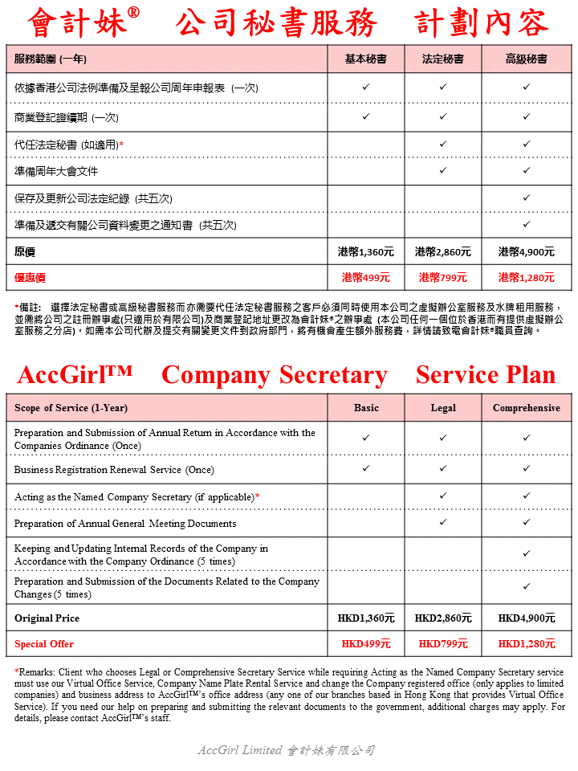

**附件三: 虛擬辦公室服務計劃**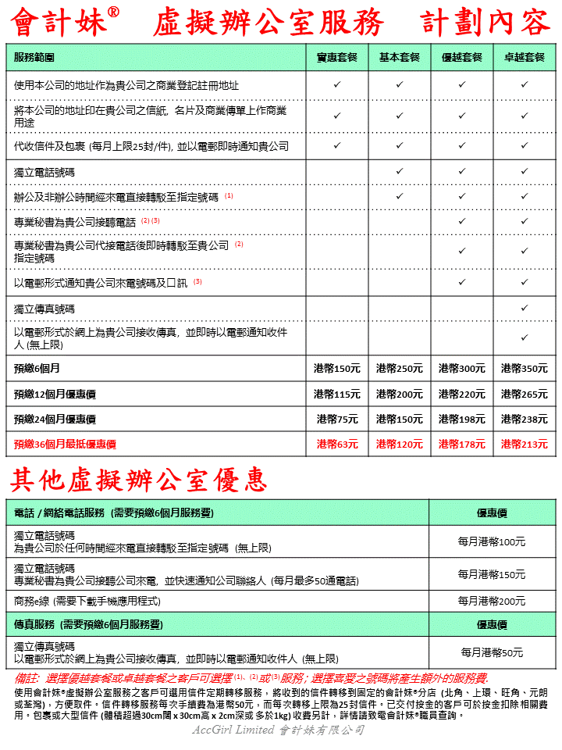

**Appendix C: Virtual Office Service Plan Information**